Dear Sir/Madam,

At Arnbrook Primary School, we do all we can to ensure that all our pupils, no matter their circumstances, achieve well and that nothing holds them back. That’s why we provide a free, healthy breakfast for all our pupils, every day. For the last year, our breakfast bagels have been provided by a government funded scheme. In July 2020, this funding will end. We need to raise £3,000 to keep the scheme running throughout 2020/21 and provide bagels for every child who needs them. We would be grateful for any donations received to help this scheme continue, through our new Just Giving Page.

We are proud to serve our local community and privileged to provide an outstanding education for over two hundred amazing pupils. Unfortunately, many of our children and families live in poverty and we witness the effects of this on our pupils’ education. We see many children come to school hungry, having had no breakfast, which means they struggle to concentrate in lessons. We serve over 100 bagels every morning and it’s had a huge impact:

Feedback from parents and carers has been amazing. Parents and carers tell us that their children ‘Can’t wait to get to school to have a bagel’ & ‘They give them a healthy start to the day’.

100% of our teachers have noticed pupils ‘have more energy’ and are ‘less distracted’ since our bagels began. We’ve also seen pupils’ attendance and punctuality improve hugely.

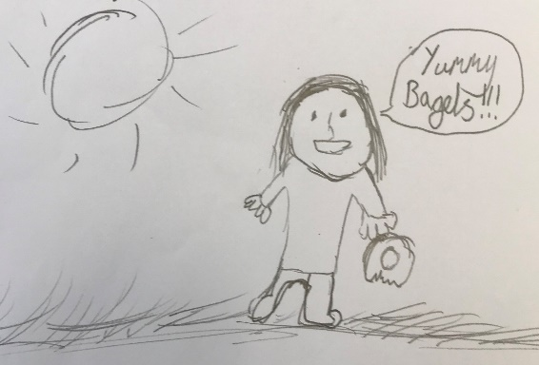

Children tell us…

‘Bagels make me happy…they’re my favourite!’

‘I feel ready to learn.’

‘I feel energetic and focused.’

One of our fantastic pupils, aged 8.

Money raised through our Just Giving page will go directly to paying for the weekly delivery of bagels for our pupils and their preparation. To run the scheme, we must raise our target of £3,000 before July 2020.

Thank you for taking the time to read this letter. Any donations can be made through <https://www.justgiving.com/crowdfunding/arnbrookprimary> and will be gratefully received. We are happy to feature information about any donors on our website, letters and social media. If you have any questions, please don’t hesitate to get in touch,

Yours sincerely,



Mr. Peter Fowlie

Headteacher